Business Intelligence And Big Data Analytics

Mini Project

Aim: Implementation Of Mongo DB

Steps:

Steps to Install MongoDB:

1) Steps to install mongodb in debian based distro
2) Import the public key used by the package management system.
- From a terminal, issue the following command to import the MongoDB public GPG Key
- wget -qO - https://www.mongodb.org/static/pgp/server-5.0.asc | sudo apt-key add -
- The operation should respond with an OK.
- However, if you receive an error indicating that gnupg is not installed, you can:
- Install gnupg and its required libraries using the following command:
- sudo apt-get install gnupg
- Once installed, retry importing the key:
- wget -qO - https://www.mongodb.org/static/pgp/server-5.0.asc | sudo apt-key add -
3) Create a /etc/apt/sources.list.d/mongodb-org-5.0.list file for MongoDB.
- Create the list file using the command appropriate for your version of Debian:
- Debian 10 Buster:
- echo "deb http://repo.mongodb.org/apt/debian buster/mongodb-org/5.0 main" | sudo tee /etc/apt/sources.list.d/mongodb-org-5.0.list
4)Reload local package database.
- Issue the following command to reload the local package database:
- sudo apt-get update
5) Install the MongoDB packages.
- You can install either the latest stable version of MongoDB or a specific version of MongoDB.
- To install the latest stable version, issue the following
- sudo apt-get install -y mongodb-org

Run Mongo DB:

1) Start MongoDB.
- You can start the mongod process by issuing the following command:
- sudo systemctl start mongod
- If you receive an error similar to the following when starting mongod:
- Failed to start mongod.service: Unit mongod.service not found.
- Run the following command first:
- sudo systemctl daemon-reload
- Then run the start command above again.
2) Verify that MongoDB has started successfully.
- sudo systemctl status mongod
- You can optionally ensure that MongoDB will start following a system reboot by issuing the following command:
- sudo systemctl enable mongod
3) Stop MongoDB.
- As needed, you can stop the mongod process by issuing the following command:
- sudo systemctl stop mongod
4) Restart MongoDB.
- You can restart the mongod process by issuing the following command:
- sudo systemctl restart mongod
- You can follow the state of the process for errors or important messages by watching the output in the /var/log/mongodb/mongod.log file.
5) Begin using MongoDB.
- Start a mongosh session on the same host machine as the mongod. You can run mongosh without any command-line options to connect to a mongod that is running on your localhost with default port 27017.
- mongosh

Start Mongosh:

1) >mongosh
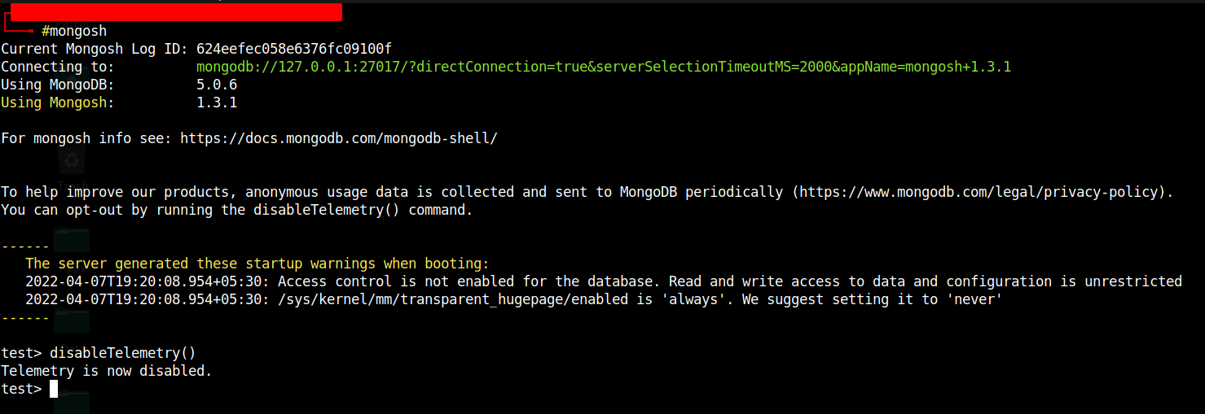

2) Check for any existing databases.
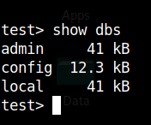

3) Create a new database
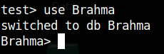

4) Insert value to the DB
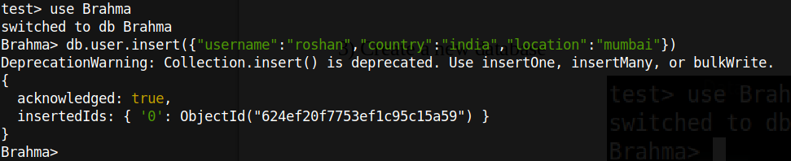
5) Show the inserted value
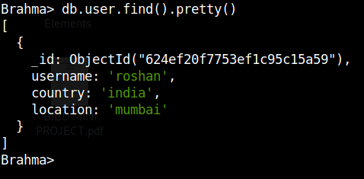

6) To drop a database
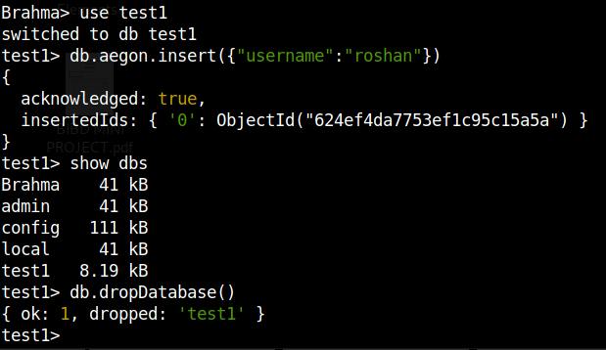
7) Create Value
- insertOne
- insertMany
InsertOne
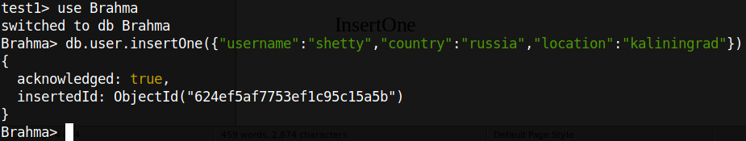
InsertMany
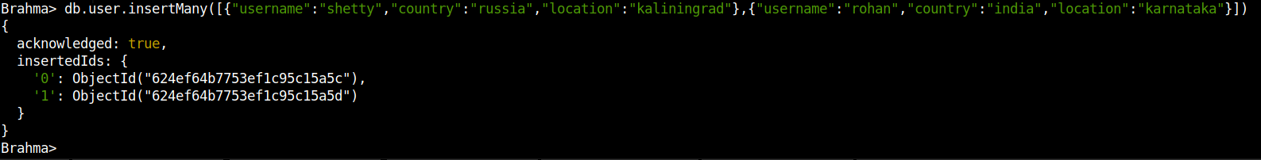
Check the Database

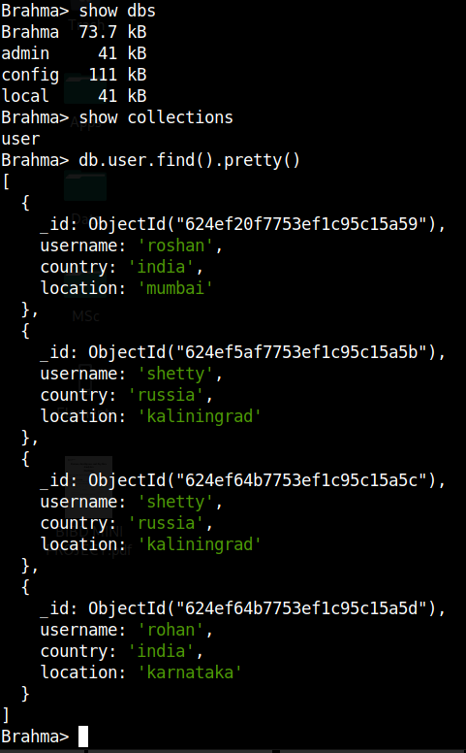

8) Updating a value
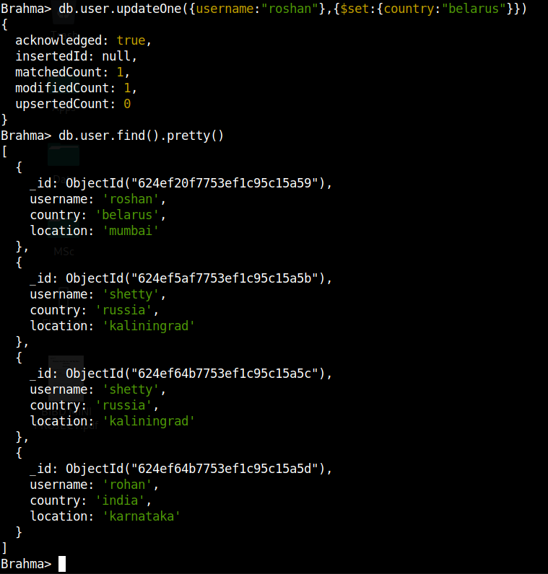

9) updateMany
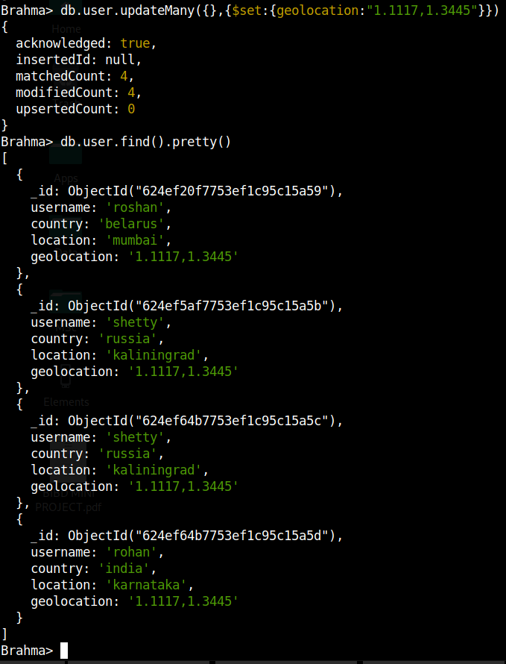

10) Update single value

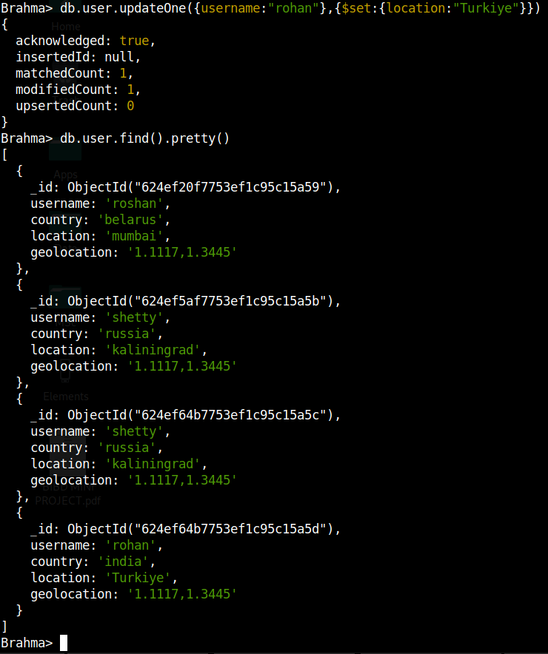

11) Find command to find particular tag

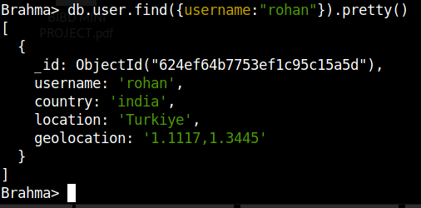

12) deleteOne

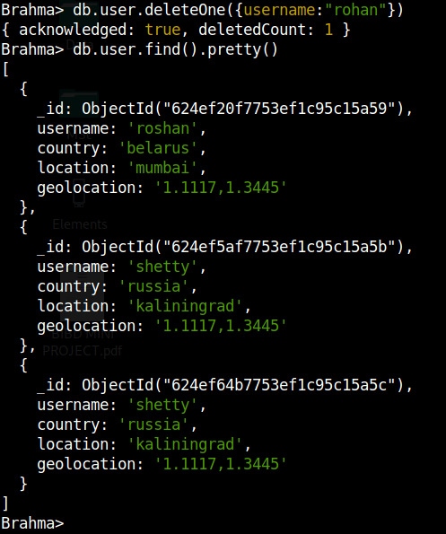

13) DeleteMany
